3/22/2024 – Mozingo Lake Golf Course
Graceland Spring Invitational Women Results:
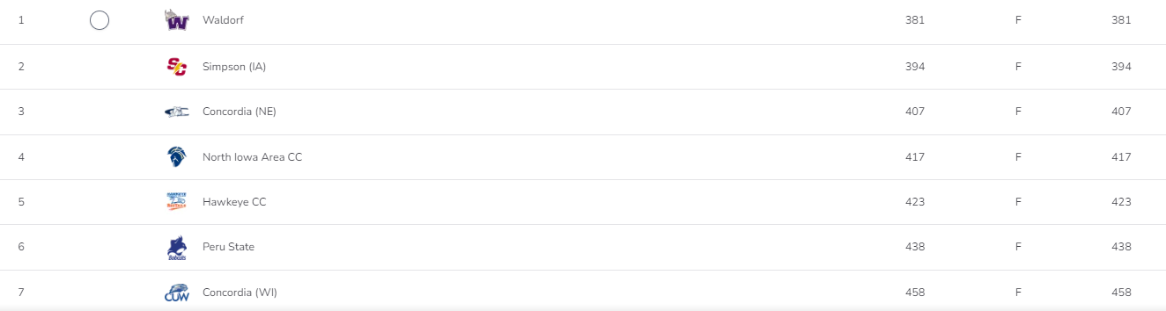
Players:
